z
1/1/2026
SUBASH SUBEDI

MPLS & VPLS Backbone Design based on Islington College Using GNS3 and MikroTik
MIKROTIK PROJECT
Scenario
Islington College operates a multi-block campus network consisting of 9 academic and administrative blocks. The college owns a public IPv4 address range (160.30.132.0/24), which must be used for router loopback interfaces within an MPLS backbone.

We are required to design, implement, and verify an MPLS-based core network using MikroTik routers in GNS3, providing VPLS-based Layer-2 connectivity across all blocks while using a centralized DHCP server.

The LONDON_BLOCK is the main block, connected to the Internet (ISP), and all other blocks connect to it directly and via additional mesh links for redundancy and load balancing.

Network Architecture and IP Addressing Plan:

Core Design
- All block routers act as MPLS core routers
- OSPF is the IGP across all routers
- MPLS with LDP must be enabled on all core and mesh links
- ECMP / Load balancing must be implemented
- VPLS must be used to extend VLANs across all blocks
- No DHCP service should run on any router

Use the following explicit IP addressing scheme. All loopback addresses are from the public IPv4 range 160.30.132.0/24 (160.30.132.0 to 160.30.132.255). Do not use any other IPs for loopbacks or links.

Block Routers and Loopback IPs
- LONDON_BLOCK (main block, connected to ISP): Loopback IP 160.30.132.1/32
- UK_BLOCK: Loopback IP 160.30.132.11/32
- NEPAL_BLOCK: Loopback IP 160.30.132.12/32
- HIMAL_BLOCK: Loopback IP 160.30.132.13/32
- BRIT_BLOCK: Loopback IP 160.30.132.14/32
- SKILL_BLOCK: Loopback IP 160.30.132.15/32
- KUMARI_BLOCK: Loopback IP 160.30.132.16/32
- ALUMNI_BLOCK: Loopback IP 160.30.132.17/32

Point-to-Point Links from LONDON_BLOCK (Private IPs, /30 subnets):
- LONDON_BLOCK to UK_BLOCK: 10.0.0.0/30 (LONDON_BLOCK: 10.0.0.1, UK_BLOCK: 10.0.0.2)
- LONDON_BLOCK to NEPAL_BLOCK: 10.0.0.4/30 (LONDON_BLOCK: 10.0.0.5, NEPAL_BLOCK: 10.0.0.6)
- LONDON_BLOCK to HIMAL_BLOCK: 10.0.0.8/30 (LONDON_BLOCK: 10.0.0.9, HIMAL_BLOCK: 10.0.0.10)
- LONDON_BLOCK to BRIT_BLOCK: 10.0.0.12/30 (LONDON_BLOCK: 10.0.0.13, BRIT_BLOCK: 10.0.0.14)
- LONDON_BLOCK to SKILL_BLOCK: 10.0.0.16/30 (LONDON_BLOCK: 10.0.0.17, SKILL_BLOCK: 10.0.0.18)
- LONDON_BLOCK to KUMARI_BLOCK: 10.0.0.20/30 (LONDON_BLOCK: 10.0.0.21, KUMARI_BLOCK: 10.0.0.22)
- LONDON_BLOCK to ALUMNI_BLOCK: 10.0.0.24/30 (LONDON_BLOCK: 10.0.0.25, ALUMNI_BLOCK: 10.0.0.26)

Mesh Connections (Router-to-Router Private IPs, /30 subnets for redundancy):
- UK_BLOCK to NEPAL_BLOCK: 10.0.0.28/30 (UK_BLOCK: 10.0.0.29, NEPAL_BLOCK: 10.0.0.30)
- UK_BLOCK to HIMAL_BLOCK: 10.0.0.32/30 (UK_BLOCK: 10.0.0.33, HIMAL_BLOCK: 10.0.0.34)
- UK_BLOCK to BRIT_BLOCK: 10.0.0.36/30 (UK_BLOCK: 10.0.0.37, BRIT_BLOCK: 10.0.0.38)
- HIMAL_BLOCK to SKILL_BLOCK: 10.0.0.40/30 (HIMAL_BLOCK: 10.0.0.41, SKILL_BLOCK: 10.0.0.42)
- SKILL_BLOCK to ALUMNI_BLOCK: 10.0.0.44/30 (SKILL_BLOCK: 10.0.0.45, ALUMNI_BLOCK: 10.0.0.46)
- ALUMNI_BLOCK to KUMARI_BLOCK: 10.0.0.48/30 (ALUMNI_BLOCK: 10.0.0.49, KUMARI_BLOCK: 10.0.0.50)
- KUMARI_BLOCK to BRIT_BLOCK: 10.0.0.52/30 (KUMARI_BLOCK: 10.0.0.53, BRIT_BLOCK: 10.0.0.54)

VLANs and End-Device Subnets (Provided by Centralized DHCP):
- VLAN 100 (STUDENT): 172.16.0.0/19 (capacity for 5,000 student IPs)
- VLAN 200 (TEACHER): 172.16.32.0/19 (capacity for 1,000 teacher IPs)
- VLAN 300 (STAFF): 172.16.36.0/21 (capacity for 2,000 staff IPs)

Table of Contents
1. Set Identity, Loopback Address and RoMON to all Routers 1
1.1. LONDON-BLOCK 1
1.2. UK-BLOCK 2
1.3. NEPAL-BLOCK 3
1.4. HIMAL-BLOCK 4
1.5. BRIT-BLOCK 5
1.6. SKILL-BLOCK 6
1.7. ALUMNI-BLOCK 7
1.8. KUMARI-BLOCK 8
2. Configuration IP in the Core Interface of all Routers 9
2.1. LONDON-BLOCK 9
2.2. UK-BLOCK 9
2.3. NEPAL-BLOCK 9
2.4. HIMAL-BLOCK 9
2.5. BRIT-BLOCK 9
2.6. SKILL-BLOCK 10
2.7. ALUMNI-BLOCK 10
2.8. KUMARI-BLOCK 10
3. Configuration OSPF to all Core Routers 11
3.1. LONDON-BLOCK 11
3.2. UK-BLOCK 11
3.3. NEPAL-BLOCK 11
3.4. HIMAL-BLOCK 11
3.5. BRIT-BLOCK 11
3.6. SKILL-BLOCK 11
3.7. ALUMNI-BLOCK 11
3.8. KUMARI-BLOCK 11
4. Configuration MPLS to all Core Routers 13
4.1. LONDON-BLOCK 13
4.2. UK-BLOCK 13
4.3. NEPAL-BLOCK 13
4.4. HIMAL-BLOCK 13
4.5. BRIT-BLOCK 13
4.6. SKILL-BLOCK 13
4.7. ALUMNI-BLOCK 13
4.8. KUMARI-BLOCK 13
5. Configuration LDP on Interfaces of Core Routers 14
5.1. LONDON-BLOCK 14
5.2. UK-BLOCK 14
5.3. NEPAL-BLOCK 14
5.4. HIMAL-BLOCK 14
5.5. BRIT-BLOCK 14
5.6. SKILL-BLOCK 14
5.7. ALUMNI-BLOCK 14
5.8. KUMARI-BLOCK 14
6. Set MPLS MTU (Crucial for VPLS to prevent fragmentation) 16
6.1. LONDON-BLOCK 16
6.2. UK-BLOCK 16
6.3. NEPAL-BLOCK 16
6.4. HIMAL-BLOCK 16
6.5. BRIT-BLOCK 16
6.6. SKILL-BLOCK 16
6.7. ALUMNI-BLOCK 16
6.8. KUMARI-BLOCK 16
7. VPLS Setup (Points to Points) Routers 17
7.1. LONDON-BLOCK 17
7.2. UK-BLOCK 17
7.3. NEPAL-BLOCK 17
7.4. HIMAL-BLOCK 17
7.5. BRIT-BLOCK 17
7.6. SKILL-BLOCK 17
7.7. ALUMNI-BLOCK 17
7.8. KUMARI-BLOCK 17
8. VPLS Configuration for VLAN Transport 19
8.1. LONDON-BLOCK 19
8.2. UK-BLOCK 19
8.3. NEPAL-BLOCK 19
8.4. HIMAL-BLOCK 19
8.5. BRIT-BLOCK 19
8.6. SKILL-BLOCK 19
8.7. ALUMNI-BLOCK 19
8.8. KUMARI-BLOCK 19
9. End-to-End Verification and Traffic Analysis 20
9.1. LONDON-BLOCK 20
9.2. UK-BLOCK 20
9.3. NEPAL-BLOCK 20
9.4. HIMAL-BLOCK 20
9.5. BRIT-BLOCK 20
9.6. SKILL-BLOCK 20
9.7. ALUMNI-BLOCK 20
9.8. KUMARI-BLOCK 20
10. Conclusion and Future Enhancements 21
11. a 21

List of Figures

Figure 1: Set Identity, Loopback Address and RoMoN of LONDON_BLOCK Router Through CMD 1
Figure 2: Set Identity, Loopback Address and RoMoN of LONDON_BLOCK Router Through WINBOX 1
Figure 3: Set Identity, Loopback Address and RoMoN of UK-BLOCK Router Through CMD 2
Figure 4: Set Identity, Loopback Address and RoMoN of UK-BLOCK Router Through WINBOX 2
Figure 5: Set Identity, Loopback Address and RoMoN of NEPAL-BLOCK Router Through CMD 3
Figure 6: Set Identity, Loopback Address and RoMoN of NEPAL-BLOCK Router Through WINBOX 3
Figure 7: Set Identity, Loopback Address and RoMoN of NEPAL-BLOCK Router Through CMD 4
Figure 8: Set Identity, Loopback Address and RoMoN of NEPAL-BLOCK Router Through WINBOX 4
Figure 9: Set Identity, Loopback Address and RoMoN of BRIT-BLOCK Router Through CMD 5
Figure 10: Set Identity, Loopback Address and RoMoN of BRIT-BLOCK Router Through WINBOX 5
Figure 11: Set Identity, Loopback Address and RoMoN of SKILL-BLOCK Router Through CMD 6
Figure 12: Set Identity, Loopback Address and RoMoN of SKILL-BLOCK Router Through WINBOX 6
Figure 13: Set Identity, Loopback Address and RoMoN of ALUMNI-BLOCK Router Through CMD 7
Figure 14: Set Identity, Loopback Address and RoMoN of ALUMNI-BLOCK Router Through WINBOX 7
Figure 15: Set Identity, Loopback Address and RoMoN of KUMARI-BLOCK Router Through CMD 8
Figure 16: Set Identity, Loopback Address and RoMoN of KUMARI-BLOCK Router Through WINBOX 8

List of Tables

Set Identity, Loopback Address and RoMON to all Routers

LONDON-BLOCK
CMD
/system identity set name=LONDON-BLOCK

/interface bridge add name=loopback comment="LONDON-BLOCK_160.30.132.1_LOOPBACK"

/ip address add address=160.30.132.1/32 interface=loopback comment="LONDON-BLOCK_160.30.132.1_LOOPBACK"

/tool/romon/set enabled=yes

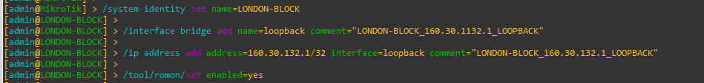
Figure 1: Set Identity, Loopback Address and RoMoN of LONDON_BLOCK Router Through CMD
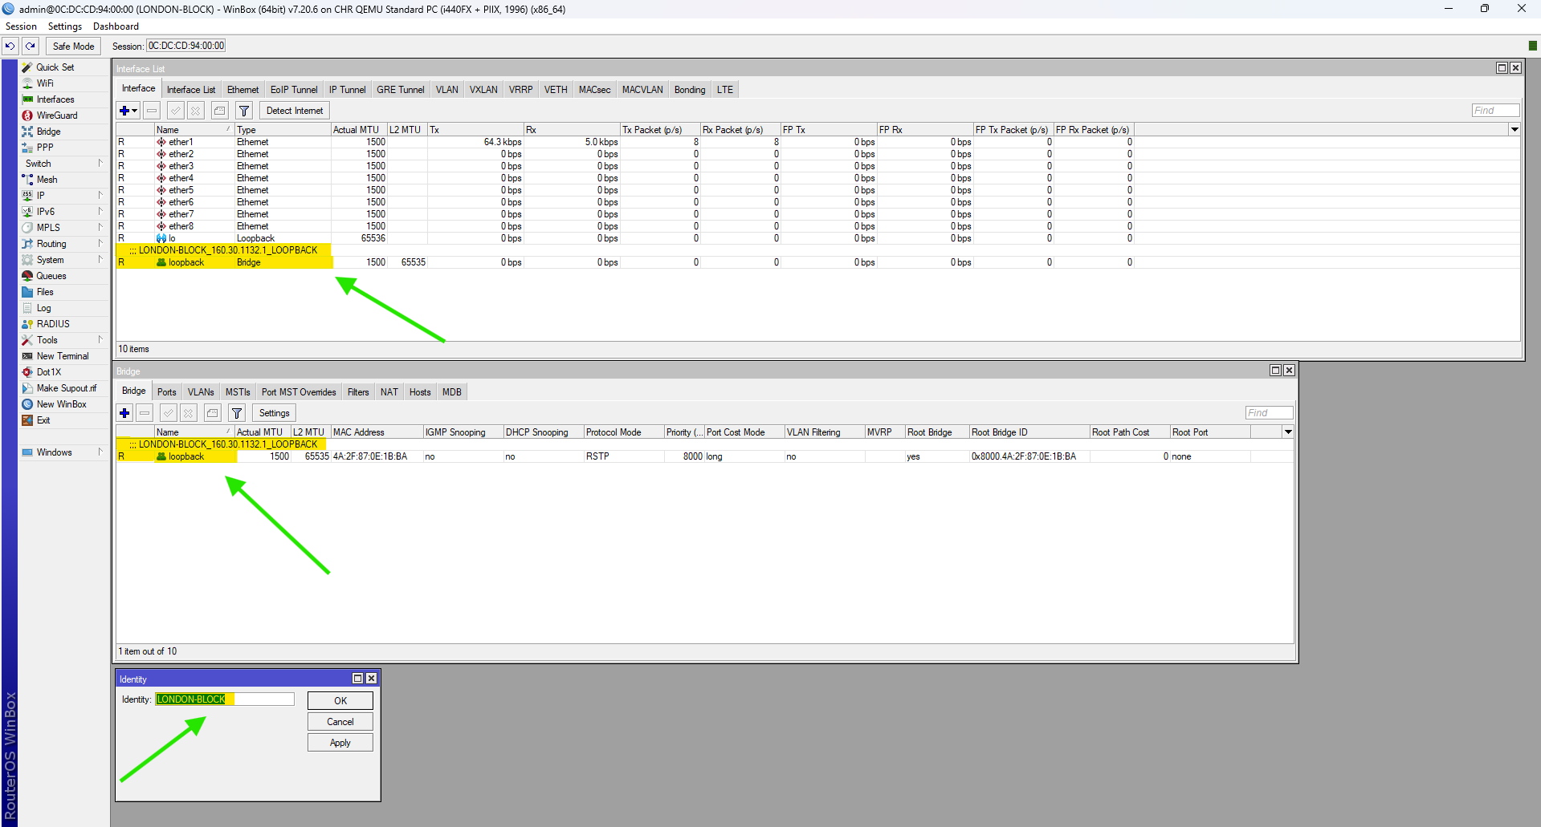
Figure 2: Set Identity, Loopback Address and RoMoN of LONDON_BLOCK Router Through WINBOX

UK-BLOCK
CMD
/system identity set name= UK-BLOCK

/interface bridge add name=loopback comment=" UK-BLOCK_160.30.132.11_LOOPBACK"

/ip address add address=160.30.132.11/32 interface=loopback comment=" UK-BLOCK_160.30.132.11_LOOPBACK"

/tool/romon/set enabled=yes

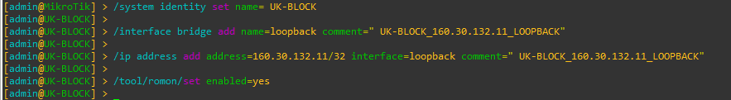
Figure 3: Set Identity, Loopback Address and RoMoN of UK-BLOCK Router Through CMD
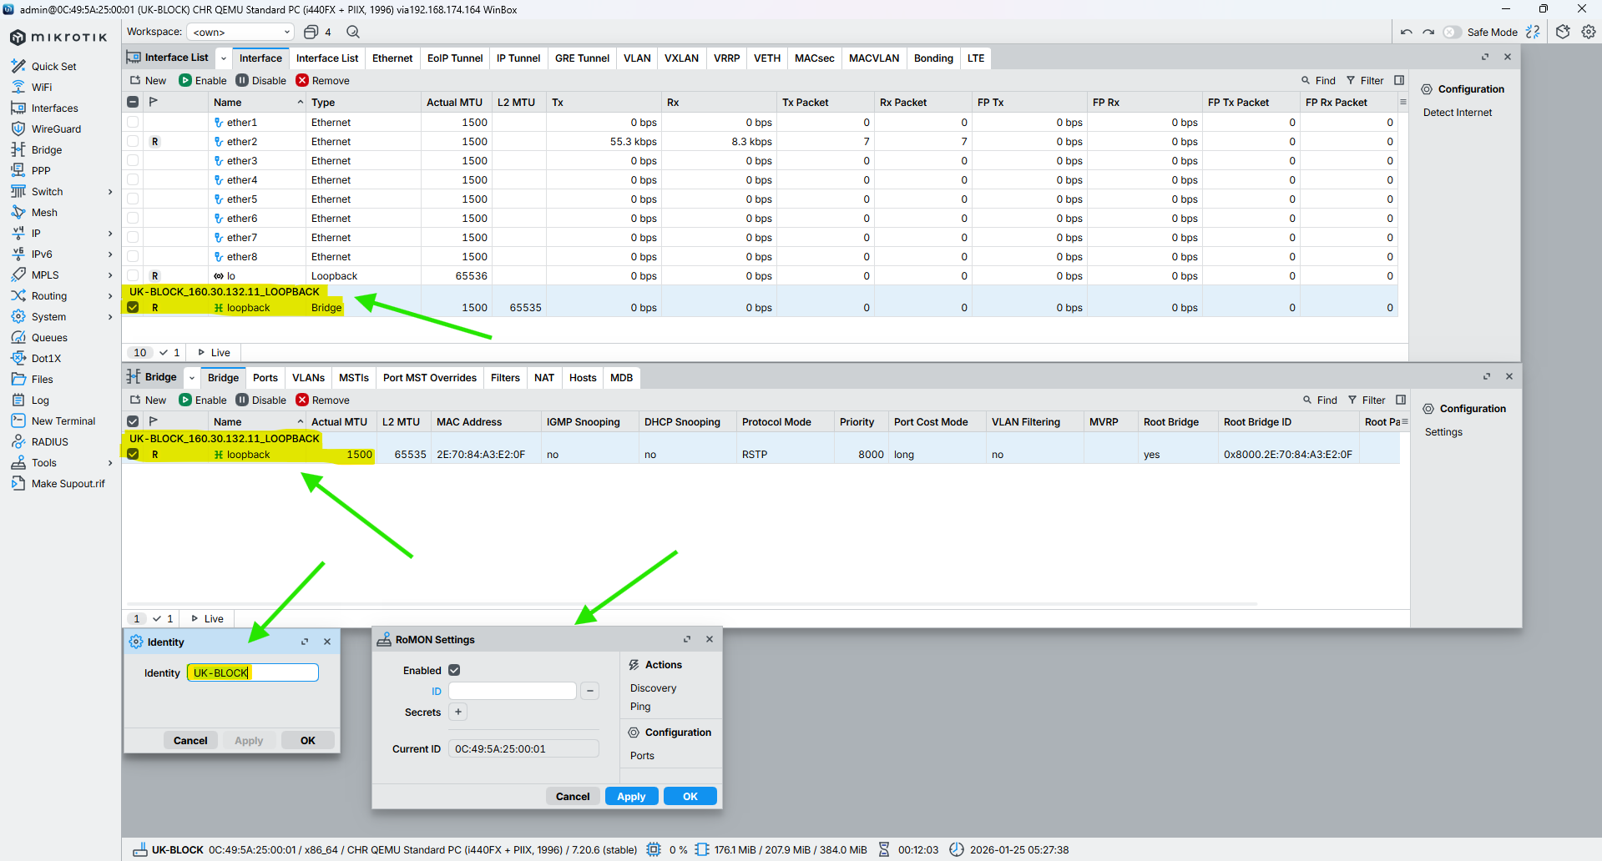
Figure 4: Set Identity, Loopback Address and RoMoN of UK-BLOCK Router Through WINBOX

NEPAL-BLOCK
CMD
/system identity set name=NEPAL-BLOCK

/interface bridge add name=loopback comment="NEPAL-BLOCK_160.30.132.12_LOOPBACK"

/ip address add address=160.30.132.12/32 interface=loopback comment="NEPAL-BLOCK_160.30.132.12_LOOPBACK"

/tool/romon/set enabled=yes

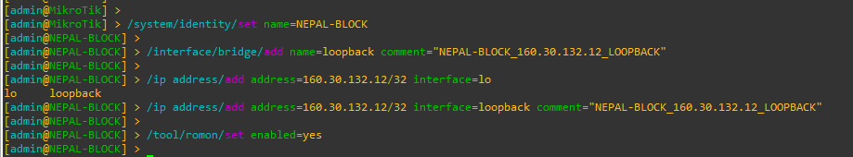
Figure 5: Set Identity, Loopback Address and RoMoN of NEPAL-BLOCK Router Through CMD
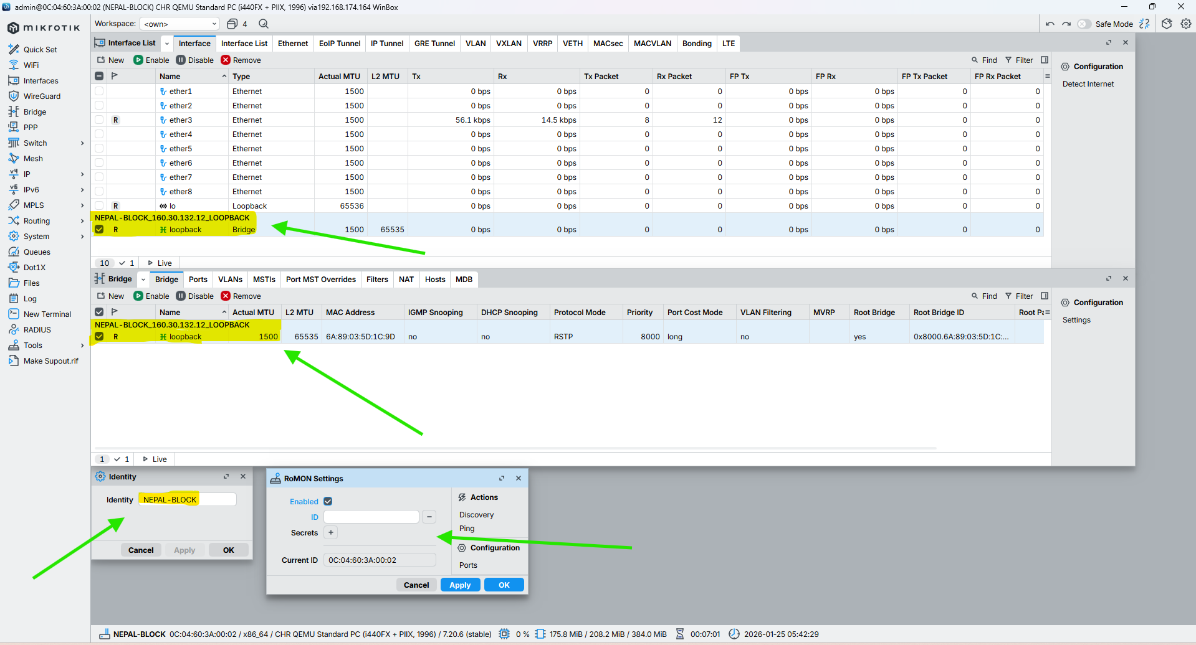
Figure 6: Set Identity, Loopback Address and RoMoN of NEPAL-BLOCK Router Through WINBOX

HIMAL-BLOCK
CMD
/system identity set name=HIMAL-BLOCK

/interface bridge add name=loopback comment="HIMAL-BLOCK_160.30.132.13_LOOPBACK"

/ip address add address=160.30.132.13/32 interface=loopback comment="HIMAL-BLOCK_160.30.132.13_LOOPBACK"

/tool/romon/set enabled=yes

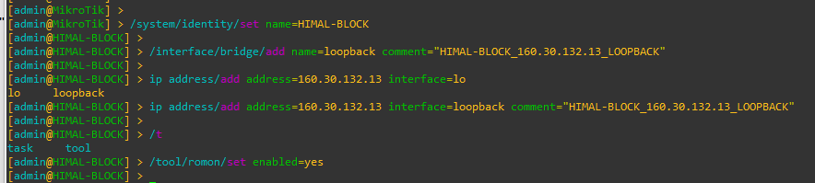
Figure 7: Set Identity, Loopback Address and RoMoN of NEPAL-BLOCK Router Through CMD
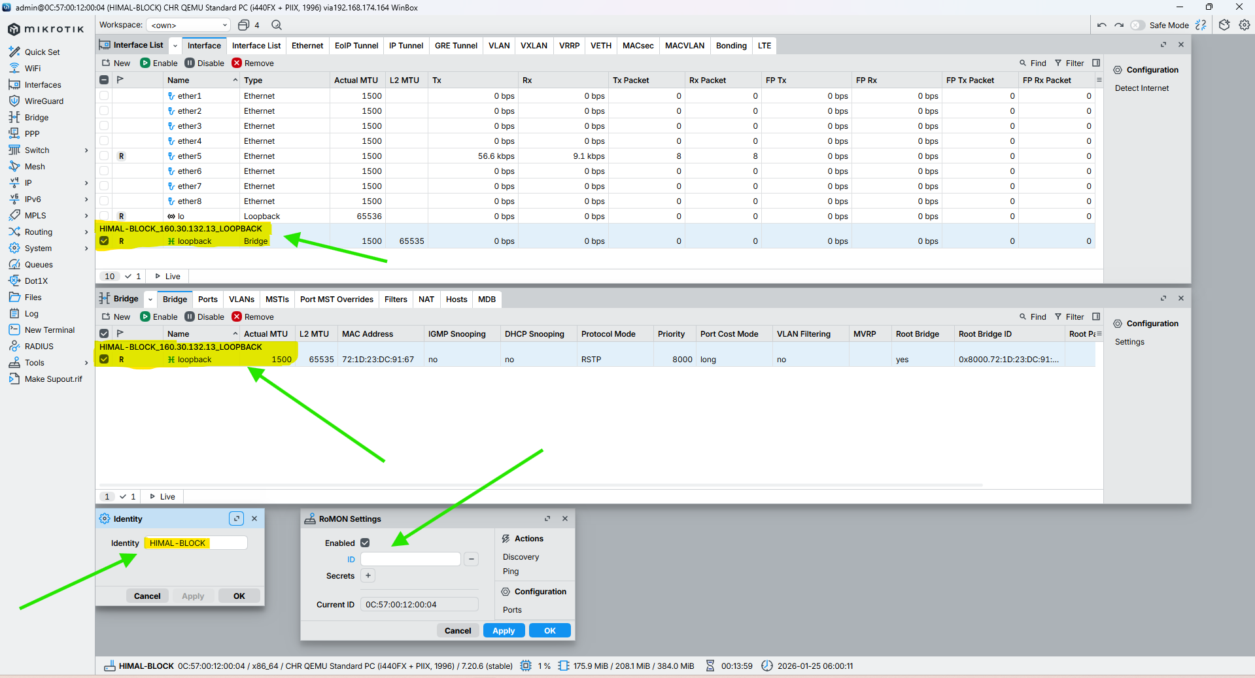
Figure 8: Set Identity, Loopback Address and RoMoN of NEPAL-BLOCK Router Through WINBOX

BRIT-BLOCK
CMD
/system identity set name=BRIT-BLOCK

/interface bridge add name=loopback comment="BRIT-BLOCK_160.30.132.14_LOOPBACK"

/ip address add address=160.30.132.14/32 interface=loopback comment="BRIT-BLOCK_160.30.132.14_LOOPBACK"

/tool/romon/set enabled=yes

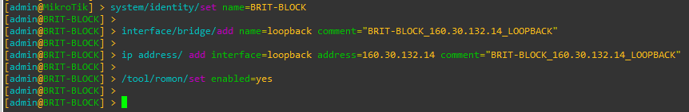
Figure 9: Set Identity, Loopback Address and RoMoN of BRIT-BLOCK Router Through CMD
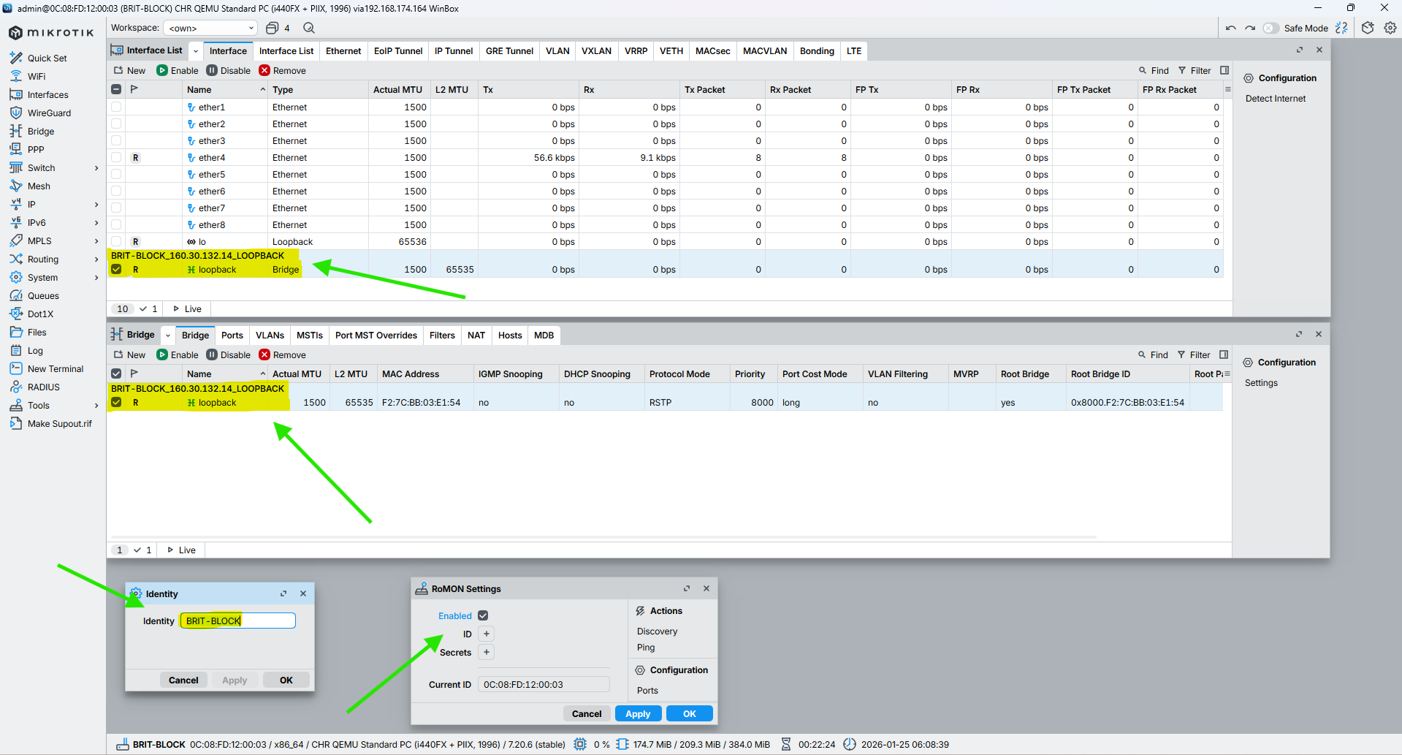
Figure 10: Set Identity, Loopback Address and RoMoN of BRIT-BLOCK Router Through WINBOX

SKILL-BLOCK
CMD
/system identity set name=SKILL-BLOCK

/interface bridge add name=loopback comment="SKILL-BLOCK_160.30.132.14_LOOPBACK"

/ip address add address=160.30.132.14/32 interface=loopback comment="SKILL-BLOCK_160.30.132.14_LOOPBACK"

/tool/romon/set enabled=yes

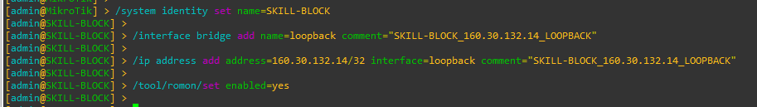
Figure 11: Set Identity, Loopback Address and RoMoN of SKILL-BLOCK Router Through CMD
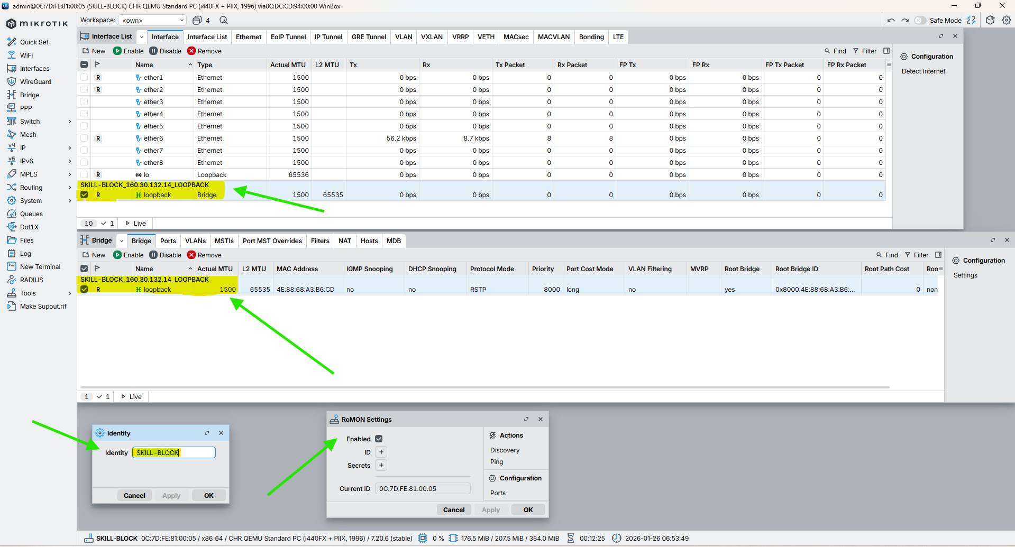
Figure 12: Set Identity, Loopback Address and RoMoN of SKILL-BLOCK Router Through WINBOX

ALUMNI-BLOCK
CMD
/system identity set name=ALUMNI-BLOCK

/interface bridge add name=loopback comment="ALUMNI-BLOCK_160.30.132.15_LOOPBACK"

/ip address add address=160.30.132.15/32 interface=loopback comment="ALUMNI-BLOCK_160.30.132.15_LOOPBACK"

/tool/romon/set enabled=yes

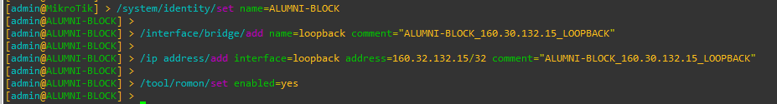
Figure 13: Set Identity, Loopback Address and RoMoN of ALUMNI-BLOCK Router Through CMD
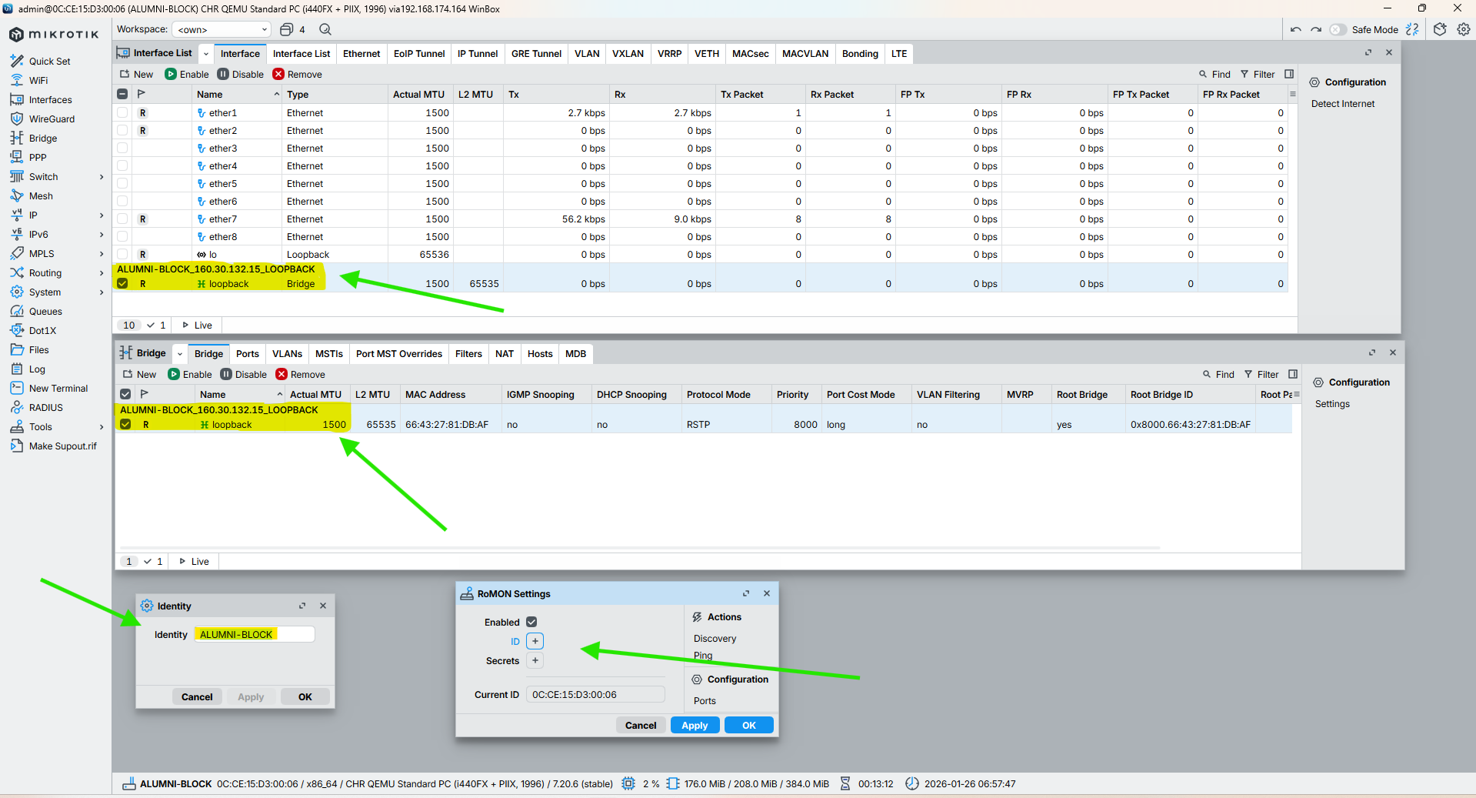
Figure 14: Set Identity, Loopback Address and RoMoN of ALUMNI-BLOCK Router Through WINBOX

KUMARI-BLOCK
CMD
/system identity set name=KUMARI-BLOCK

/interface bridge add name=loopback comment="KUMARI-BLOCK_160.30.132.16_LOOPBACK"

/ip address add address=160.30.132.16/32 interface=loopback comment="KUMARI-BLOCK_160.30.132.16_LOOPBACK"

/tool/romon/set enabled=yes

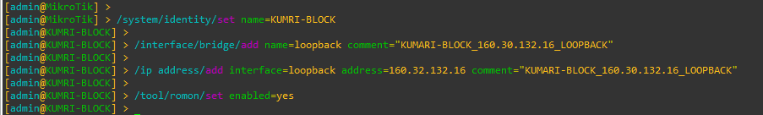
Figure 15: Set Identity, Loopback Address and RoMoN of KUMARI-BLOCK Router Through CMD
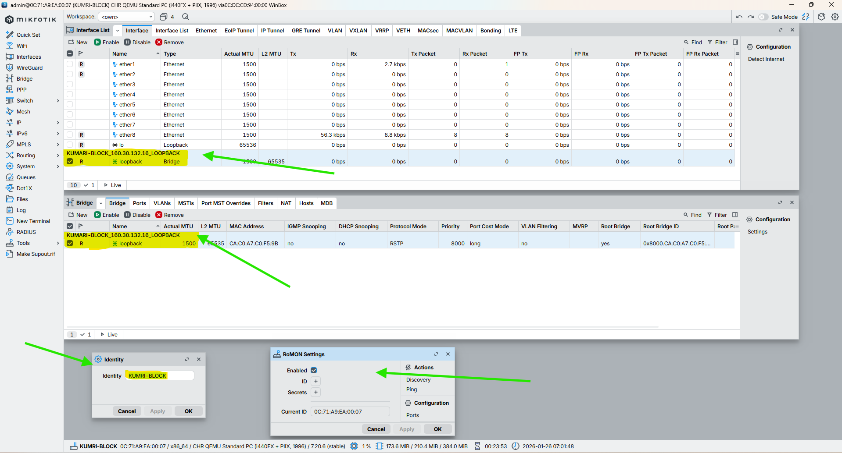
Figure 16: Set Identity, Loopback Address and RoMoN of KUMARI-BLOCK Router Through WINBOX

Configuration IP in the Core Interface of all Routers

LONDON-BLOCK
CMD
/ip address add address=10.0.0.1/30 interface=ether2 comment="LINK FROM LONDON-BLOCK_10.0.0.1/30 TO UK-BLOCK_10.0.0.2/30"

/ip address add address=10.0.0.5/30 interface=ether3 comment="LINK FROM LONDON-BLOCK_10.0.0.5/30 TO NEPAL-BLOCK_10.0.0.6/30"

/ip address add address=10.0.0.9/30 interface=ether4 comment="LINK FROM LONDON-BLOCK_10.0.0.9/30 TO BRIT-BLOCK_10.0.0.10/30"

/ip address add address=10.0.0.13/30 interface=ether5 comment="LINK FROM LONDON-BLOCK_10.0.0.13/30 TO HIMAL-BLOCK_10.0.0.14/30"

/ip address add address=10.0.0.17/30 interface=ether6 comment="LINK FROM LONDON-BLOCK_10.0.0.17/30 TO SKILL-BLOCK_10.0.0.18/30"

/ip address add address=10.0.0.21/30 interface=ether7 comment="LINK FROM LONDON-BLOCK_10.0.0.21/30 TO ALUMNI-BLOCK_10.0.0.22/30"

/ip address add address=10.0.0.25/30 interface=ether8 comment="LINK FROM LONDON-BLOCK_10.0.0.25/30 TO KUMARI-BLOCK_10.0.0.26/30"

UK-BLOCK
CMD

NEPAL-BLOCK
CMD

HIMAL-BLOCK
CMD

BRIT-BLOCK
CMD

SKILL-BLOCK
CMD

ALUMNI-BLOCK
CMD

KUMARI-BLOCK
CMD

Configuration OSPF to all Core Routers

LONDON-BLOCK

UK-BLOCK

NEPAL-BLOCK

HIMAL-BLOCK

BRIT-BLOCK

SKILL-BLOCK

ALUMNI-BLOCK

KUMARI-BLOCK

Configuration MPLS to all Core Routers

LONDON-BLOCK

UK-BLOCK

NEPAL-BLOCK

HIMAL-BLOCK

BRIT-BLOCK

SKILL-BLOCK

ALUMNI-BLOCK

KUMARI-BLOCK

Configuration LDP on Interfaces of Core Routers

LONDON-BLOCK

UK-BLOCK

NEPAL-BLOCK

HIMAL-BLOCK

BRIT-BLOCK

SKILL-BLOCK

ALUMNI-BLOCK

KUMARI-BLOCK

Set MPLS MTU (Crucial for VPLS to prevent fragmentation)

LONDON-BLOCK

UK-BLOCK

NEPAL-BLOCK

HIMAL-BLOCK

BRIT-BLOCK

SKILL-BLOCK

ALUMNI-BLOCK

KUMARI-BLOCK

VPLS Setup (Points to Points) Routers

LONDON-BLOCK

UK-BLOCK

NEPAL-BLOCK

HIMAL-BLOCK

BRIT-BLOCK

SKILL-BLOCK

ALUMNI-BLOCK

KUMARI-BLOCK

VPLS Configuration for VLAN Transport

LONDON-BLOCK

UK-BLOCK

NEPAL-BLOCK

HIMAL-BLOCK

BRIT-BLOCK

SKILL-BLOCK

ALUMNI-BLOCK

KUMARI-BLOCK

End-to-End Verification and Traffic Analysis

LONDON-BLOCK

UK-BLOCK

NEPAL-BLOCK

HIMAL-BLOCK

BRIT-BLOCK

SKILL-BLOCK

ALUMNI-BLOCK

KUMARI-BLOCK

A

Conclusion and Future Enhancements

a

